SEMIAUTOMATIC ORBITAL WRAPPING MACHINE FV300/160
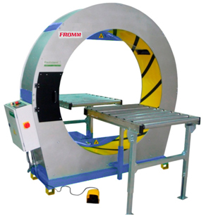
Semiautomatic machine for horizontal packaging with stretchfilm.
Applications:
Packaging, grouping and protection with stretchfilm products like furniture,
doors, timber boards, windows, frames, etc.
Working process:
The user places the product manually until the ring through the infeed
gravity roller conveyor; pressing the footswitch the machine wraps it with
stretchfilm. Finally the user take out manually the product fully wrapped
through the outfeed gravity rollers conveyor.
Standard equipment:
- Steel frame, painted in grey and base in blue colour
- Ring assembled in the frame, painted in yellow colour.
- Double reel dispenser head; allows to wrap with two reels of stretchfilm
for a reinforced wrapping and faster packaging or to wrap with one reel
for a simple wrapping; ready to use reels of different width.
- Fast changing reels without tools and with self-fixing system.
- Adjustable stretchfilm tension to fit it to the product.
- Device that unable the machine to work while changing the reel for worker safety.
- Safety footswitch to start/finish the wrapping cycle.
- Ring driver system through trapezoidal belt of low maintenance and wear.
- Control panel and electrical box: Master switch, power light, warning light, reset button & emergency stop.
- Steel packaging around the frame base for transport.
- Machine certificate meeting CE safety standards (2006/42/CE, 2004/42/CE & 93/68/CEE).
Optional accessories:
- Double automatic stretchfilm clamp and cutter system for two reels which includes:
  - Semiautomatic stretchfilm threading for reel changing.
  - Stopping system to place the reel dispenser head in the exact position for reel changing.
  - Adjustable extra wrapping laps in both ends of the product for a higher protection.
  - Ring speed controller (driver included) to adjust the stretchfilm overlap onto the product.
  - Touch colour screen to programme and to adjust the machine to the specifications of the product to be wrapped (extra wrapping laps in the ends of the product, stretchfilm threading, 6 wrapping programmes, warning messages, reels change, only ends wrapping, 6 languages programmes).
- Ring speed controller (driver included) to adjust the stretchfilm overlap onto the product.
- Gravity rollers conveyor W31.5 x L39 in (suggested).
- Gravity rollers conveyor + tilter system to place product from vertical to horizontal W47in x L59in.
- Table with 3 gravity rollers in triangle to wrap round products.
- Rollers side guide with manual fitting.
- Short products bridge < 23.5 in.
- Top presser with manual fitting.
- Manual bubblewrap top dispenser (integrated on machine) for reel up to 47in.
- Manual bubblewrap floor dispenser for reel up to 47in.
- Remote technical assistance (via Internet).
- No standard machine colour.
- Seafreight wooden crate.
- Seafreight wooden box.
Technical specifications:
Product to wrap sizes:
- Maximum / minimum length | : No limit / 23.5in or 15.5in with short products bridge.
- Width and height | : Check with graphic.
Electrical equipment:
- Electrical tension | : 400V III+N.  : 110V I. (for configuration with cutting system)
- Engine | : 2.011 hp
- Manoeuvre | : 24V c.c.
- Electrical consumption | : 0.697 hp
- Ring rotation speed | : 5 to 50 rpm (For configuration with speed inverter)
- Speed inverter | : Fuji (according to the configuration).
- PLC | : Omron (according to the configuration).
- Pneumatic pressure | : 6 bars (for configuration with cutting system).
- Compressed air consumption | : 24 liters/cycle (for configuration with cutting system).
Stretchfilm or paper* reel specifications:
- Width | : 10, 6.5 or 4 in.
- Thickness | : 80, 90, 120, 140 or 200 gauge.
- External / Internal Ø | : 9 / 1.5 in.
- Colour | : Transparent / opaque.
(*) Only for configuration without cutting system.
Installed machine sizes | : Check attached drawing.
Packed machine sizes | : 8.35 x 7.38 x 5 ft - 1874 lb.
Packed film reels sizes | : 3.3 x 4 x 6 ft - 1726 lb.
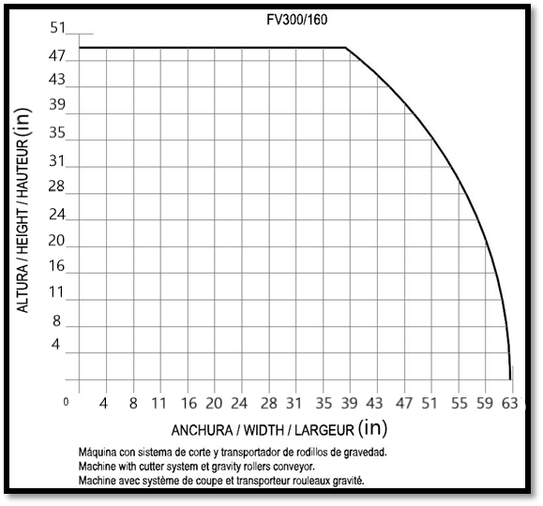 |  |  | 