SEMIAUTOMATIC ORBITAL WRAPPING MACHINE FV300/090
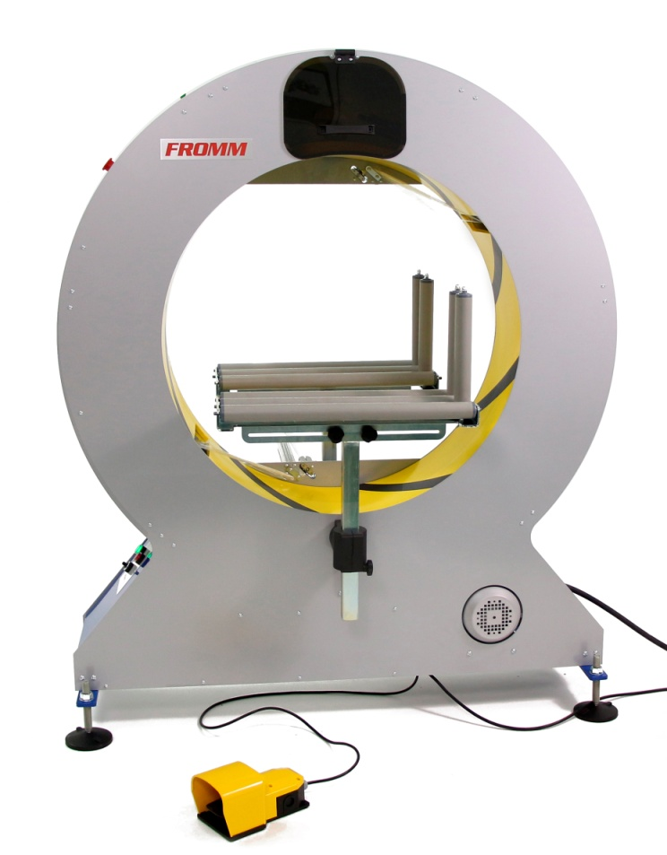
Semiautomatic machine for horizontal packaging with stretchfilm.
Applications:
Packaging, grouping and protection with stretchfilm of products like
mouldings, flooring, profiles, aluminium bars tubes, blinds, etc.
Working process:
The user places the product manually until the ring through the
infeed gravity rollers conveyor; pressing the footswitch the
machine wraps it with stretchfilm. Finally the user take out
manually the product fully wrapped through the outfeed gravity
rollers conveyor.
Standard equipment:
- Steel frame, painted in grey and base in blue colour
- Ring assembled in the frame, painted in yellow colour.
- Double reel dispenser head; allows to wrap with two reels of
stretchfilm for a reinforced wrapping and faster packaging or to wrap
with one reel for a simple wrapping; ready to use reels of different width.
- Fast changing reels without tools and with self-fixing system.
- Adjustable stretchfilm tension to fit it to the product.
- Adjustable rotation ring speed to control the stretchfilm overlap
onto the product.
- Device that unable the machine to work while changing the reel for worker safety.
- Safety footswitch to start/finish the wrapping cycle.
- Ring driver system through trapezoidal belt of low maintenance and wear.
- Control panel and electrical box: Master switch, power light, warning light, reset button, speed controller & emergency stop.
- Packaging in wooden pallet for transport.
- Machine certificate meeting CE safety standards (2006/42/CE, 2004/42/CE & 93/68/CEE).
Accessories (optional):
- Double automatic stretchfilm clamp and cutter system for two reels.
- Infeed & outfeed gravity rollers table for product feeding (suggested).
- Gravity rollers conveyors.
- Side vertical rollers “V” shape.
- Short products bridge.
- Top presser with manual fitting.
- Wheels with brake.
- Manual bubblewrap floor dispenser for reel up to 47 in.
- No standard machine colour.
- Seafreight wooden crate.
- Seafreight wooden box.

Technical specifications:
Product to wrap sizes:
- Maximum / minimum length | : No limit / 14 in or 10 in with short products bridge.
- Width and height | : Check with graphic.
Electrical equipment:
- Power | : 110V I.
- Engine | : 1 hp
- Manoeuvre | : 24V c.c.
- Power consumption | : 0.41 hp
- Ring rotation speed | : 5 to 90 rpm.
- Speed inverter | : Omron.
- PLC | : Omron.
- Pneumatic pressure | : 6 bars (for configuration with cutting system).
- Compressed air consumption | : 5 liters/cycle (for configuration with cutting system).
Stretchfilm or paper* reel specifications.
- Width | : 4 or 6.5 in.
- Thickness | : 68, 80, 90 or 120 gauge.
- External / Internal Ø | : 7.9 / 1.5 in.
- Colour | : Transparent / opaque.
(*)Only for configuration without cutting system.
Installed machine sizes | : Check attached drawing.
Packed machine sizes | : 5 x 3.5 x 6 ft – 410 lb.
Packed film reels sizes | : 3.3 x 3.94 x 6.45 ft - 1600 lb.
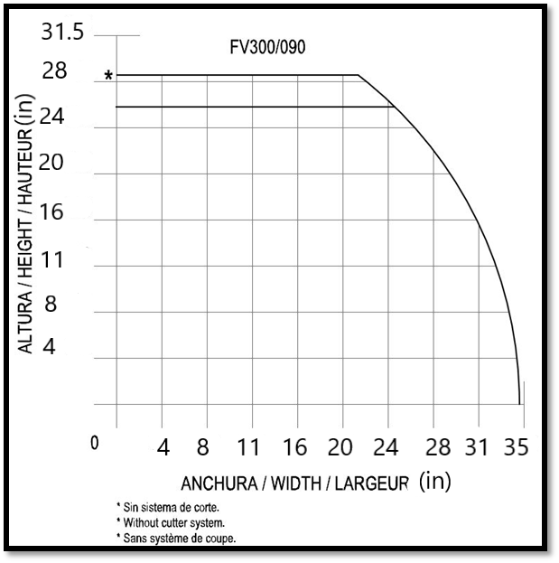 |  | 