AUTOMATIC ORBITAL WRAPPING MACHINE FV350/200
Automatic machine for horizontal packaging with stretchfilm.
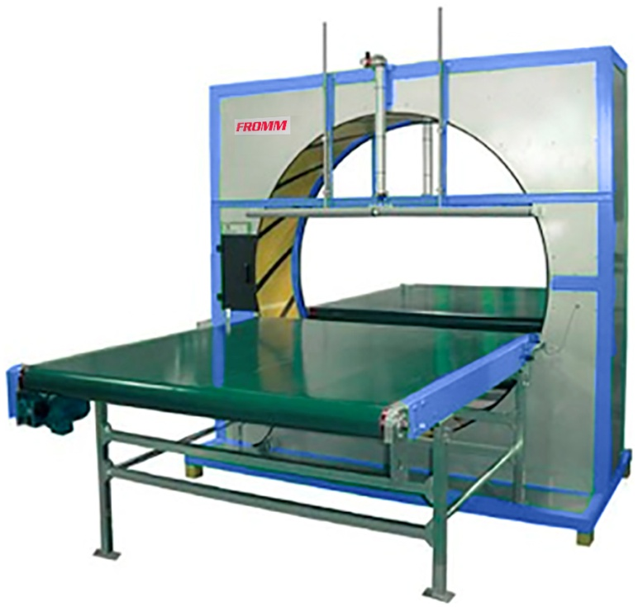
Applications:
Packaging, grouping and protection with stretchfilm products like furniture, doors,
timber boards, windows, frames, etc.
Working process:
Product arrives automatically until the ring of the wrapping machine
through an infeed driven conveyor; the electrical photocell detects the
product and the machine wraps it with stretchfilm. Finally, an outfeed driven
conveyor belt push out the product fully wrapped.
Standard equipment:
- Steel frame, painted in grey and base in blue colour
- Ring assembled in the frame, painted in yellow colour.
- Double reel dispenser head; allows to wrap with two reels
of stretchfilm for a reinforced wrapping and faster packaging or
to wrap with one reel for a simple wrapping; ready to use reels of
different width.
- Adjustable stretchfilm tension to fit it to the product.
- Fast changing reels without tools and with self-fixing system.
- Double automatic stretchfilm clamp and cutter system for two reels.
- Automatic stretchfilm threading for reel changing.
- Stopping system to place the reel dispenser head in the exact position for reel changing.
- Adjustable extra wrapping laps in both ends of the product for a higher protection.
- Ring speed controller (driver included) to adjust the stretchfilm overlap onto the product.
- Touch colour screen to program and adjust the machine to the specifications of the product to be wrapped with: Extra wrapping laps in the ends of the product, stretchfilm threading, 6 wrapping programs, warning messages, reels change, only ends wrapping, 6 languages programs, presses on/off, infeed top press up time control, outfeed top press down time control and conveyors stopping time.
- Wrapping programs (6): standard program (wrapping from end to end of the product), bundling program (to wrap product ends only) and four programs else to be issued by the user.
- Backwards conveyors selector and selector product goes through the ring but without wrapping; this option is used in machines which are set up in automatic lines where some products do not need to be wrapped.
- Variable driven conveyors speed to control the wrapping speed or to adjust stretchfilm overlap onto the product.
- Electrical photocell to start the wrapping cycle.
- Device that unable the machine to work while changing the reel for worker safety.
- Ring driver system through trapezoidal belt of low maintenance and wear.
- Control panel and electrical box with: Master switch, power light, warning light, start button, reset button ring speed control, conveyors speed control, emergency stop and touch screen.
- Tower lights to inform status of orbital wrapper.
- Steel packaging around the frame base for transport.
- Machine certificate meeting CE safety standards (2006/42/CE, 2004/42/CE & 93/68/CEE).

Optional Accessories:
- Infeed & outfeed top pressers - manual fitting.
- Infeed & outfeed top pressers - automatic fitting.
- Rollers side guide - manual fitting.
- Driven conveyor belt W47 x L39 in (other dimensions also available).
- Driven conveyor metal rollers W47 x L39 in (other dimensions also available).
- Driven conveyor chain W47 x L39 in (other dimensions also available).
- Driven conveyor belt with pneumatic lift to place corners W39 x L98.5 in.
- Driven conveyor metal rollers "V" shape W47 x L157.5 in.
- Gravity rollers conveyor + tilter system to place product from vertical to horizontal W47 x L60 in.
- Table with driven rollers (3) in triangle with pneumatic lift to wrap round products.
- Table with driven (2) in parallel to wrap round products.
- Hydraulic lift table to centre conveyor belt/rollers vs. ring.
- Short products bridge < 23.5 mm.
- Driven conveyor belts (bridge) for short products W45 x L23.5 in.
- Wooden/porex blocks automatic dispenser (includes driven conveyor for short products W45 x L23.5 in).
- Warning of reel end.
- Safety fences + safety kit.
- Remote technical assistance (via Ethernet).
- No standard machine colour.
- Seafreight wooden crate.
- Seafreight wooden box.
- Manual bubblewrap top dispenser (integrated on machine) for reel up to 63 in.
- Manual bubblewrap floor dispenser for reel up to 63 in.
- Automatic top & bottom bubblewrap reel dispenser up to W63 in
Includes:
  - Welding bar by electrical resistances to join the ends of the top and bottom bubblewrap reels.
  - Welding temperature control to adjust the temperature depending on the bubblewrap thickness.
  - Top and bottom bubblewrap reel dispenser; top reel to cover top side product length and bottom reel to cover bottom side product length.
  - Electrical photocell to start automatically the wrapping cycle.
  - Driven feeding of top and bottom bubblewrap reels, to avoid product pulls directly from them.
  - Selector to cancel the automatic dispenser and to allow machine wrapping with stretchfilm only.
  - Tower lights to inform status of dispenser.
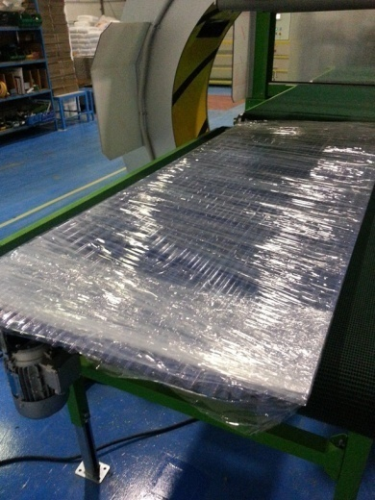 |  |  | 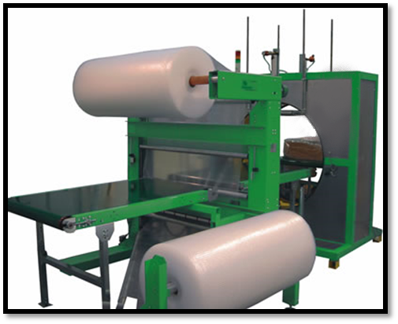
* Mod. with conveyor belts (optional)
automatic top presses (optional)
and automatic bubble wrap dispenser (optional).
Technical specifications:
Product to wrap sizes:
- Maximum / minimum length |  |  |  | : Unlimited / 23.5 in. (15.7 in. with bridge).
- Other sizes |  |  |  | : Check with graphic.
- Minimum sizes |  |  |  | : 15.7 x 15.7 x 23.5 in.(L)
Recommended conveyor belt specifications:
- Useful width |  |  |  | : 47 in.
- Length |  |  |  | : 39 in.
- Working height |  |  |  | : Adjustable.
- Engine |  |  |  | : 0.496 hp*.
- Lineal speed |  |  |  | : From 10 fpm up to 33 fpm.
- Max. weight to convey |  |  |  | : 165 lb / lineal meter.
(*) Speed inverter for inner driven conveyor 1 hp. and exit driven conveyor 1 hp.
Electrical equipment: |  |  |  |  |  | 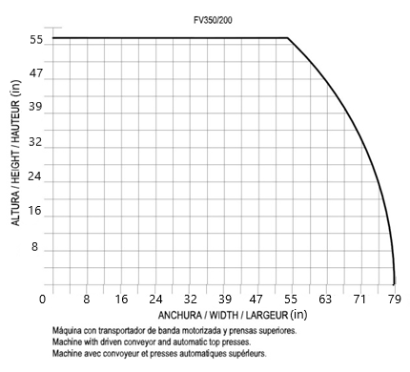
- Engine |  | : 4 hp.
- Power supply |  | : 400V III+N.
- Manoeuvre |  | : 24V c.c.
- Power consumption |  | : 2.23 hp.
- Ring rotation speed |  | : From 5 to 55 rpm.
- Speed inverters |  | : Fuji.
- Programmable PLC |  | : Omron.
- Pneumatic pressure |  | : 6 bars.
- Compressed air consumption |  | : 45 liters/cycle.
Stretchfilm reel specifications:
- Width | : 10, 6.5 or 4 in.
- Thickness | : 90,120,140 or 200 gauge.
- External / internal Ø | : 9 / 1.5 in.
- Colours | : Transparent / opaque.
Installed machine sizes |  |  |  | : Check attached drawing.
Packed machine sizes |  |  |  | : 10 x 5 x 8.6 ft. – 2535 lb.
Packed film reels sizes |  |  |  | : 3.3 x 3.9 x 6 ft. – 1726 lb.
Technical specifications with automatic bubble wrap / polyethylene dispenser (optional)
Electrical equipment:
- Engine |  |  |  | : 5.42 hp.
- Power consumption |  |  |  | : 2.53 hp.
Welding bar:
- Width |  |  |  | : 71 in.
- Electrical resistances |  |  |  | : 10 units.
Bubble wrap / Polyethylene reel specifications:
- Type |  |  |  | : Triple layer reel
- Width |  |  |  | : 71 in. |  |  | / 71 in.
- Length |  |  |  | : 492 ft. |  |  | / 1312 ft.
- Ø external |  |  |  | : 31.5 in. |  |  | / 12 in.
Installed machine sizes |  |  |  | : Check attached drawing.
Packed machine sizes |  |  |  | : 10 x 5 x 8.6 ft. – 2535 lb. / 7.5 x 6.25 x 8 ft. - 1984 lb.
Packed film reels sizes |  |  |  | : 3.3 x 3.9 x 6 ft. – 1726 lb.

