AUTOMATIC ORBITAL WRAPPING MACHINE FV350/050
Automatic machine for horizontal packaging with stretchfilm.
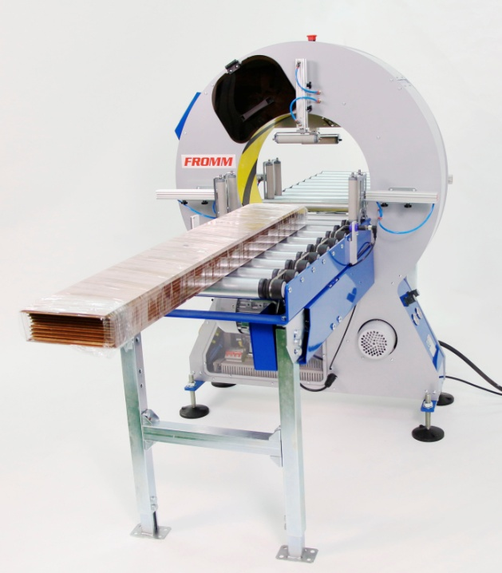
Applications:
Packaging, grouping and protection with stretchfilm of products like
mouldings, flooring, profiles, aluminium bars tubes, blinds, etc.
Working process:
Product arrives automatically until the ring of the wrapping
machine through an infeed driven conveyor; the electrical photocell
detects the product and the machine wraps it with stretchfilm.
Finally, an outfeed driven conveyor push out the product fully wrapped.
Standard equipment:
- Steel frame, painted in grey and base in blue colour
- Ring assembled in the frame, painted in yellow colour.
- Double reel dispenser head; allows to wrap with two reels of
stretchfilm for a reinforced wrapping and faster packaging or to
wrap with one reel for a simple wrapping; ready to use reels of
different width.
- Fast changing reels without tools and with self-fixing system.
- Adjustable stretchfilm tension to fit it to the product.
- Double automatic stretchfilm clamp and cutter system for two reels.
- Automatic stretchfilm threading for reel changing.
- Stopping system to place the reel dispenser head in the exact position for reel changing.
- Adjustable extra wrapping laps in both ends of the product for a higher protection.
- Adjustable rotation ring speed to control the stretchfilm overlap onto the product.
- Touch colour screen to program and adjust the machine to the specifications of the product to be wrapped with: Extra wrapping laps in the ends of the product, stretchfilm threading, 6 wrapping programs, warning messages, reels change, only ends wrapping, 6 languages programs, presses on/off, infeed top press up time control, outfeed top press down time control and conveyors stopping time.
- Wrapping programs (6): standard program (wrapping from end to end of the product), bundling program (to wrap product ends only) and four programs else to be issued by the user.
- Backwards conveyors selector and selector product goes through the ring but without wrapping; this option is used in machines which are set up in automatic lines where some products do not need to be wrapped.
- Variable driven conveyors speed to control the wrapping speed or to adjust stretchfilm overlap onto the product.
- Electrical photocell to start the wrapping cycle.
- Device that unable the machine to work while changing the reel for worker safety.
- Ring driver system through trapezoidal belt of low maintenance and wear.
- Control panel and electrical box with: Master switch, power light, warning light, start button, reset button ring
speed control, conveyors speed control, emergency stop and touch screen.
- Tower lights to inform status of orbital wrapper.
- Packaging in wooden pallet for transport.
- Machine certificate meeting CE safety standards (2006/42/CE, 2004/42/CE & 93/68/CEE).

Optional Accessories:
- Infeed & outfeed top pressers, manual fitting, to hold the product.
- Infeed & outfeed top pressers, automatic fitting, to hold the product.
- Side vertical rollers, manual fitting, to guide and/or to group the product.
- Side vertical rollers, automatic fitting (pneumatic), to guide and/or to group the product
- Driven conveyor metal rollers W19.5 x L39 in (other dimensions also available).
- Driven conveyor belt W23.5 x L39 in (other dimensions also available).
- Driven conveyor metal rollers "V" shape W23.5 x L79 in.
- Automatic system to load laterally the product to be wrapped.
- Automatic pneumatic system to remove the wrapped products laterally.
- Automatic driven system to remove the wrapped products laterally.
- Short products bridge.
- Wheels with brake.
- Warning of reel end.
- Safety fences + safety kit.
- Remote technical assistance (via Ethernet).
- No standard machine colour.
- Seafreight wooden crate.
- Seafreight wooden box.
- Manual bubblewrap floor dispenser for reel up to 23.5 in.
- Automatic top & bottom bubblewrap reel dispenser up to W39 in.
Includes:
  - Welding bar by electrical resistances to join the ends of the top and bottom bubblewrap reels.
  - Welding temperature control to adjust the temperature depending on the bubblewrap thickness.
  - Top and bottom bubblewrap reel dispenser; top reel to cover top side product length and bottom reel to cover bottom side product length.
  - Electrical photocell to start automatically the wrapping cycle.
  - Driven feeding of top and bottom bubblewrap reels, to avoid product pulls directly from them.
  - Selector to cancel the automatic dispenser and to allow machine wrapping with stretchfilm only.
  - Tower lights to inform status of dispenser.
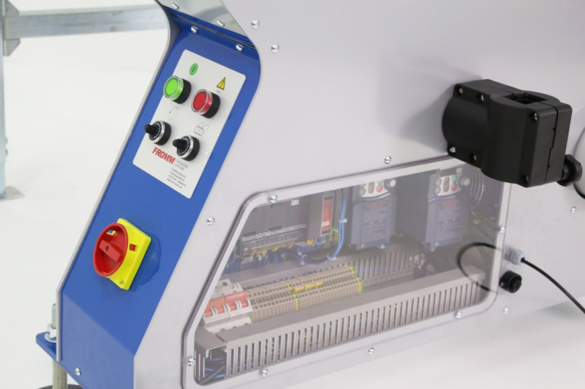 |  |  | 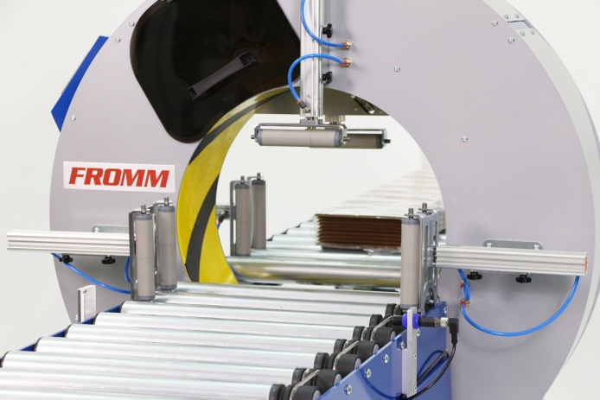
*Mod. with driven conveyors (optional)
and automatic top and lateral presses (optional).
Technical specifications:
Product to wrap sizes:
- Maximum / minimum length |  | : Unlimited / 19.5 in.
- Other sizes |  | : Check with graphic.
- Minimum sizes |  | : 2 x 2 x 19.5 in.(L)
Recommended driven conveyor specifications:
- Useful width | : 18 in.
- Length | : 39 in.
- Working height | : Adjustable.
- Engine | : 0.496 hp.
- Lineal speed | : From 26.25 fpm. up to 98.5 fpm.
- Max. weight to convey | : 110lb/ lineal meter.
(*)Speed inverter for inner driven conveyor 1 hp and exit driven conveyor 1 hp.
Electrical equipment:
- Engine |  | : 1.63 hp
- Power supply |  | : 110V I.
- Manoeuvre |  | : 24V c.c.
- Power consumption |  | : 0.858 hp
- Ring rotation speed |  | : From 5 to 180 rpm.
- Speed inverters |  | : Fuji.
- Programmable PLC |  | : Omron.
- Pneumatic pressure |  | : 6 bars.
- Compressed air consumption |  | : 6 liters/cycle.
Stretchfilm reel specifications:
- Width |  | : 3.9 in.
- Thickness |  | : 68, 90 or 120 gauge.
- External / internal Ø |  | : 7.9 / 1.5 in.
- Colours |  | : Transparent / opaque.
Installed machine sizes |  | : Check attached drawing.
Packed machine sizes |  | : 3.9 x 2.6 x 5.6 ft – 330 lb.
Packed film reels sizes |  | : 3.3 x 3.9 x 6.4 ft - 2017 lb.
