ORBITAL WRAPPING MACHINE FVA 50
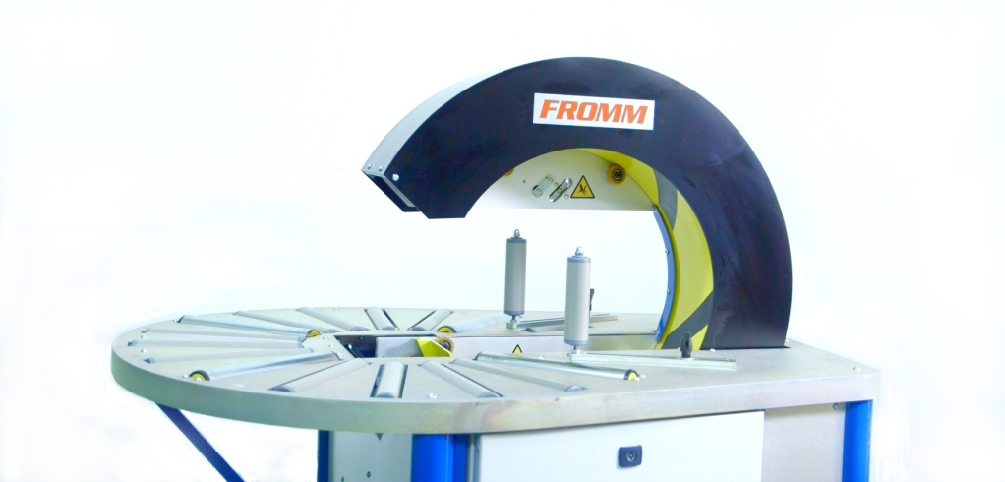
Semiautomatic machine for packaging of square or round products with stretchfilm
Applications:
Packaging and protection with stretchfilm square products such as frames,
structures and windows without glass. Also for round products such as hose
rolls, wire rolls, wheels and rings.
Working process:
The user places the product manually until the wrapping machine ring centre;
pressing the footswitch the ring closes automatically; the user
turn the product and the machine wraps it with stretchfilm;
the ring opens automatically and, finally, the user take out
the product fully wrapped.
Standard equipment:
- Steel frame, painted in grey and base in green colour
- Ring assembled in the frame, painted in yellow colour.
- Table with gravity rollers for easy feeding product through the ring.
- Double reel dispenser head; allows to wrap with two reels of stretchfilm for a reinforced wrapping and faster.
- Packaging or to wrap with one reel for a simple wrapping; ready to use reels of different width.
- Fast changing reels without tools and with self-fixing system.
- Adjustable stretchfilm tension to fit it to the product.
- Stopping system to place the reel dispenser head in the exact position for reel changing.
- Adjustable rotation ring speed to control the stretchfilm overlap onto the product.
- Safety footswitch to start/finish the wrapping cycle.
- Ring driver system through trapezoidal belt of low maintenance and wear.
- Control panel and electrical box: Master switch, power / warning light, reset button, speed controller, reel change & emergency stop.
- Packaging in wooden pallet for transport.
- Machine certificate meeting CE safety standards (2006/42/CE, 2004/42/CE & 93/68/CEE).

Accessories (optional):
- Double automatic stretchfilm clamp and cutter system for two reels.
- Table with multidirectional gravity balls for easy feeding product through the ring.
- Table with driven rollers for automatic product rotation (for round products only).
- External table with driven rollers for automatic products rotation (for round products only) (up to d.71 in).
- Side vertical roller with manual fitting to guide the product.
- Horizontal external gravity rollers to wrap profiles.
- Wheels with brake.
- Remote technical assistance (via Ethernet).
- No standard machine colour.
- Seafreight wooden crate.
- Seafreight wooden box.

Technical specifications:
Product to wrap sizes:
- Minimum inner Ø |  | : 11.5 in.
- Minimum / Maximum outer Ø |  | : 14.8 / 37.5 in.
- Minimum inner |  | : 9.5 x 9.5 in.
- Minimum outer |  | : 13.5 x 13.5 in
- Maximum thickness |  | : 8.85 in.
- Minimum / Maximum weight |  | : 11 / 55 lb.
Electrical equipment:
- Power supply |  | : 110V I.
- Engine |  | : 0.48 hp.
- Manoeuvre |  | : 24V c.c.
- Power consumption |  | : 0.45 hp.
- Ring rotation speed |  | : Adjustable up 50 rpm.
- Speed inverter |  | : Fuji.
- Automat / PLC |  | : Omron.
- Pneumatic pressure |  | : 4 bars.
- Compressed air consumption |  | : 6 liters/cycle.
Stretchfilm reel specifications:
- Width |  | : 4 in.
- Thickness |  | : 68, 80, 90 or 120 gauge.
- Ø external / internal |  | : 4.7 / 1.5 mm.
- Colour |  | : Transparent or opaque.
Installed machine sizes |  | : Check attached drawing.
Packed machine sizes |  | : 4 x 4.6 x 4.75 ft. – 440 lb.
Packed film reels sizes |  | : 3.3 x 4 x 5.5 ft. – 1929 lb.
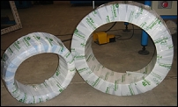 | 