ORBITAL WRAPPING MACHINE FVA 90
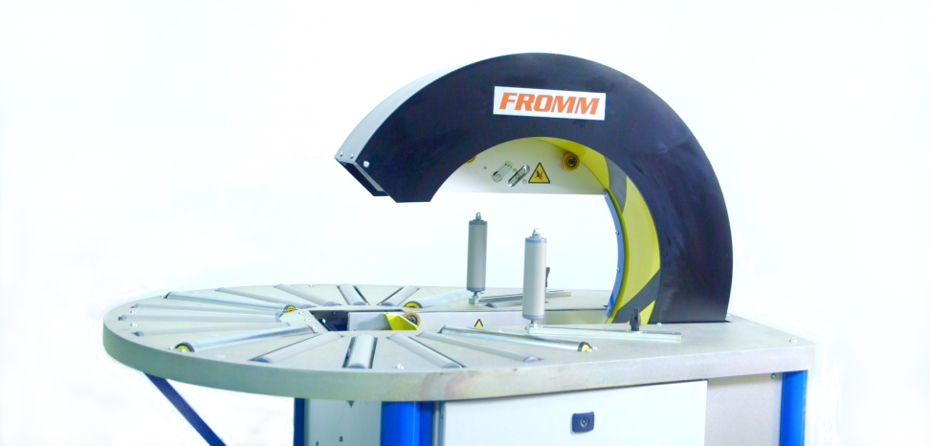
Automatic machine for horizontal packaging with stretchfilm round products
Applications:
Packaging and protection with stretchfilm round products such as hose rolls, wire
rolls, wheels and rings.
Working process:
The user places the product manually until the wrapping machine ring center;
pressing the footswitch the ring closes automatically; the
product turns automatically and the machine wraps it with
stretchfilm; the ring opens automatically and, finally, the user
take out the product fully wrapped.
Standard equipment:
- Steel frame, painted in grey and base in green colour
- Ring assembled in the frame, painted in yellow colour.
- Driven rollers table to make the rotation of product automatically.
- Double reel dispenser head; allows to wrap with two reels of stretchfilm for a reinforced wrapping and faster packaging or to wrap with one reel for a simple wrapping; ready to use reels of different width.
- Fast changing reels without tools and with self-fixing system.
- Adjustable stretchfilm tension to fit it to the product.
- Double automatic stretchfilm clamp and cutter system for two reels.
- Automatic stretchfilm threading for reel changing.
- Stopping system to place the reel dispenser head in the exact position for reel changing.
- Adjustable rotation ring speed to control the stretchfilm overlap onto the product.
- Variable driven conveyors speed to control the wrapping speed or to adjust stretchfilm overlap onto the product.
- Safety footswitch to start/finish the wrapping cycle.
- Ring driver system through trapezoidal belt of low maintenance and wear.
- Control panel and electrical box: Master switch, power/warning light, reset button, ring speed control, rollers speed control, reel change & emergency stop.
- Polycarbonate side shields.
- Packaging in wooden pallet for transport.
- Machine certificate meeting CE safety standards (2006/42/CE, 2004/42/CE & 93/68/CEE).

Accessories (optional):
- Side vertical roller with manual fitting to guide the product.
- Wheels with brake.
- Remote technical assistance (via Ethernet).
- No standard machine colour.
- Seafreight wooden crate.
- Seafreight wooden box.

Technical specifications:
Product to wrap sizes:
- Minimum inner Ø | : 13.8 in.
- Minimum / Maximum outer Ø | : 17 / 71 in.
- Minimum inner □ | : 138 x 138 in.
- Minimum outer □ | : 17.5 x 17.5 in.
- Maximum thickness | : 16.5 in.
- Minimum / Maximum weight | : 22 / 165 lb.
Electrical equipment:
- Power supply | : 110V I.
- Engine | : 1.22 hp.
- Manoeuvre | : 24V c.c.
- Power consumption | : 0.83 hp.
- Ring rotation speed | : Adjustable up 30 rpm.
- Speed inverter | : Fuji.
- Automat / PLC | : Omron.
- Pneumatic pressure | : 4 bars.
- Compressed air consumption | : 7 liters/cycle.
Stretchfilm reel specifications:
- Width | : 4 in.
- Thickness | : 68, 80, 90 or 120 gauge.
- Ø external / internal | : 4.7 / 1.5 in.
- Colour | : Transparent or opaque.
Installed machine sizes | : Check attached drawing.
Packed machine sizes | : 7 x 6 x 5.5 ft. – 816 lb.
Packed film reels sizes | : 3.3 x 4 x 5.5 ft. – 1929 lb.
